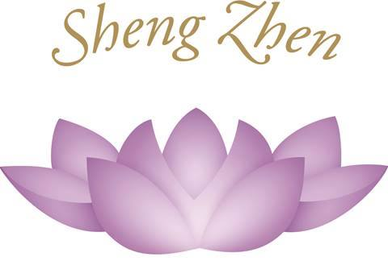
Invitation to
The Sheng Zhen Teacher Training
Israel
June 27 – July 4, 2015
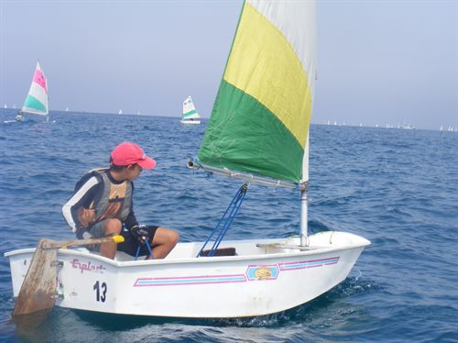

Dear Friends,

Warm greetings from the International Sheng Zhen Society!
It is with great joy that we invite you to participate in Teacher Training Course in Israel in next Summer-2015.
This will be the 4 th Teacher Training Course in Israel since 2009. As in previous Teacher Training Courses, we hope to inspire Sheng Zhen practitioners to share the gifts of the Sheng Zhen practices.

This upcoming event promises to support one's practice and teaching abilities with practical qigong teacher techniques. Furthermore it aims to introduce a broader perspective of qigong as a whole and assist in enriching one's own understanding of the practice.

Master Li Junfeng and Li Jing will conduct the 8- days intensive - Teacher Training Course.
His main focus will be on deepening our understanding of the flavor and the benefits of the Sheng Zhen Gong movements. Master Li's approach now is that the name of the form that he will teach is not so important. He will teach a variety of the different Sheng Zhen forms.

Master Li Junfeng will also have a weekend class in Tel Aviv , June 26,
& Advanced Seminar, right after the Teacher Training, in Caesarea, July 4-6 . More information about this will be on the international website: www.shengzhen.org / on Israel website : www.shengzhen.co.il, or you can contact : dina.shafrir@gmail.com /+ 972-52-2332390

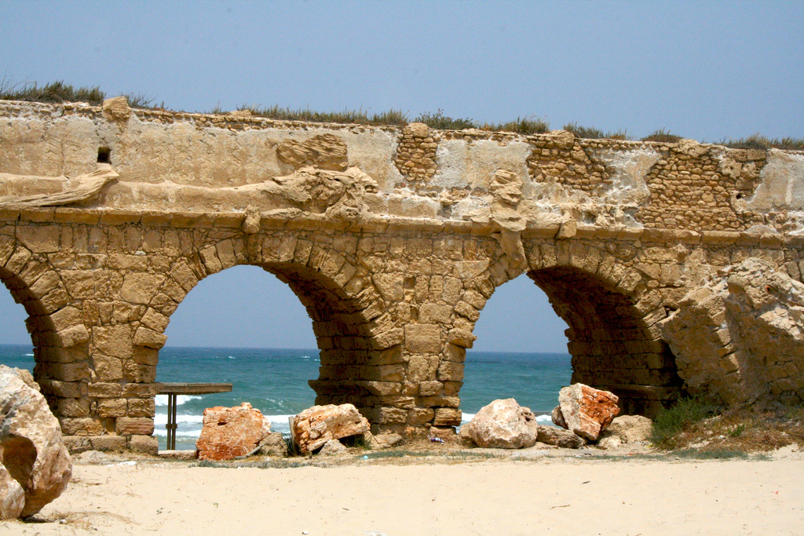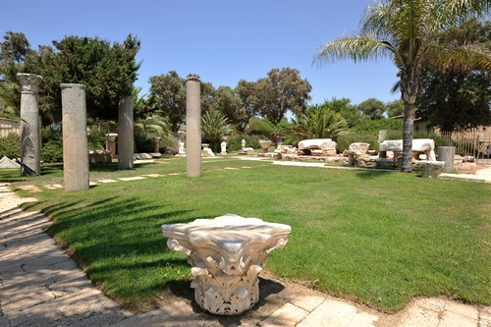

WHEN?

June 27 – July 4 - 2014.

June 26 - At 09:00 (Am) - the course starts. Information meeting and training.

July 4 - Teachers' Training Course ends after lunch.

The 8 days TT fee ---1435 $- per person. This includes accommodation
(3 people in a room), 3 meals and training fees.

WHERE?

The venue is : ' Marine Center Caesarea'
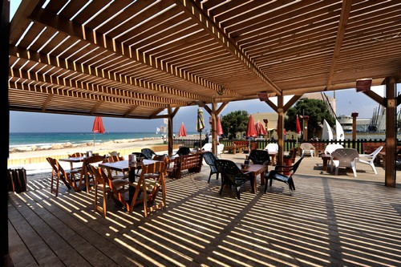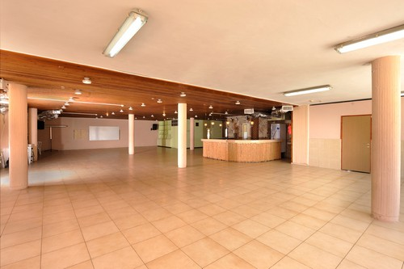

The Center is an easy train ride, only 50 minutes from Ben Gurion Airport to Caesarea.

The sea surrounding -create a restorative and peaceful environment for retreatants. June can be a hot month but the coastal location will ensure sea breezes as well as the possibility of swims.

The Caesarea Marine Center;
Beach front vacation rooms surrounded by lush vegetation near Caesarea (half an hour from Tel Aviv and Haifa.
The resort is located in one of the most attractive tourist destinations in the country, Caesarea ruins.
The sea, Caesarea ruins, sports facilities etc, are available for singles, families and groups of any kind .Those attractions and more is what makes The Caesarea Marine Center one of the leading resorts of its kind in Israel .
We will have a group excursion during the TT to some of these nearby attractions.
We’ll keep you posted on this.

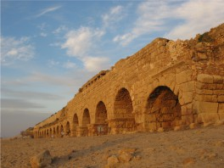


' Marine Center Caesarea'
Booking : sdot- yam, m.post menashe 37804
טל: 04-6364609/65 tel: פקס:04-6364611 fax:
z_merkazyami@sdot-yam.org.il

AIRPORT

Ben Gurion Airport

More details will be given after signing up.

INVESTMENT

- The 8 days TT fee is 1435 $, - per person.
This includes accommodation (3 people in a room), 3 meals and training fees.

- If you wish to have a double room The 8 days TT fee is –1560 $- per person.

-If you wish to have a single room- The 8 days TT fee is 1650$ per person.

*Note; we don’t use EURO in Israel, only NIS & $ (€ 1 = about 5 NIS, $ 1 = 4 NIS)

More information about payment will be sent after registration.

WHO CAN JOIN TEACHER TRAINING?
I. PREREQUISITES for ATTENDING SHENG ZHEN TEACHER TRAINING
Everyone interested in participating in teacher training is encouraged to apply. You may qualify as a Sheng Zhen Teacher in Training Participant or as a Sheng Zhen Seminar Participant. The training experience during the retreat will be the same for all participants.
First priority is given to Cert. Sheng Zhen Teachers and Sheng Zhen Teacher in Ttaining Participants. However, after 15.4.15 places will also be given to those on the seminar participants waiting list. Thereafter, places will be given on a first come, first served basis. This gives an opportunity for new aspirants to make arrangements to be able to attend. Please take note of the prerequisites written below. Application deadline is 15.4.15. Deadline for payment is 10.5.2015.

- Sheng Zhen Teacher in Training Participants Requirements
- You have studied Sheng Zhen Gong forms for a minimum of 2 years. This includes a minimum of 54 instruction hours each year from a Sheng Zhen [SZ] teacher, preferably certified, if any, with at least 12 of your hours from Master Li Junfeng or Li Jing.

or

2. You have studied Sheng Zhen Gong forms for a minimum of 1 year. This includes a minimum of 108 instruction hours from a Sheng Zhen teacher, preferably certified, if any, with at least 12 of your hours from Master Li Junfeng or Li Jing. Date you first started with the Sheng Zhen teacher will be needed when applying for certification. Please contact Don Leathers at donald@phoenixrisingmoab.com for a list of certified teachers in your area or check the SZ web site at www.shengzhen.org.

B. Sheng Zhen Seminar Participant Requirements

If you are unable to meet all of the TT prerequisites above, you may still apply to attend the TT course as a seminar participant. You must have studied with Master Li or a local Sheng Zhen Teacher, preferably certified, if any. If you attend as a seminar participant under these circumstances, your first TT session will be considered as a seminar and will not count towards teacher certification. Attending your first TT as a seminar counts as 50 hours towards the requirements for future TT’s. The second TT attended will count towards your teacher certification.

WHO CAN BECOME A SHENG ZHEN TEACHER?

II. SHENG ZHEN TEACHER CERTIFICATION REQUIREMENTS**

To be a Sheng Zhen teacher, one must understand the Sheng Zhen philosophy, live a Sheng Zhen life, respect others always (to have no conflict with others) and know the various Sheng Zhen Gong forms. All people are encouraged to share the practice with others after they have learned from Master Li, Li Jing or a local Sheng Zhen teacher.

To be considered for a Sheng Zhen Teacher certification, the MINIMUM number of teaching hours required is 180 hours of teaching experience. This includes:
- Attending 2 Teacher Trainings within 2 years (each count as 50 hours towards the total 180 hours), and
- Having practiced teaching Sheng Zhen Gong forms for a MINIMUM of 80 hours. This equates to a 1-hour class per week for 40 weeks over two years or two 1-hour classes per week for 40 weeks in one year. Note: This does not include demonstrations or leading a group in the movements, but practicing teaching the SZ forms.

To maintain certification, a certified SZ teacher must attend at least one Sheng Zhen Teacher Training Course every 2 years .
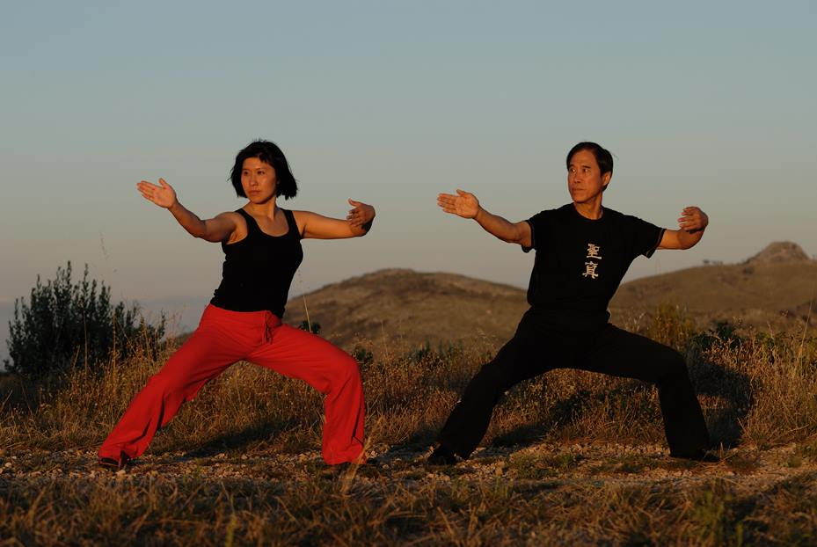
HOW TO APPLY FOR TEACHER TRAINING

Once you decide you want to join a TT, there are 2 things you need to submit with your application registration form:
1 - A Letter of Recommendation [LOR]
is required only if you have never attended TT before and is written by a SZ teacher, preferably certified, on your behalf. The letter should state that you have fulfilled the prerequisites and that you are ready to attend a TT. You may find a Certified Sheng Zhen Teacher listed at www.shengzhen.org or contact your local Sheng Zhen teacher for more information.
2 - A Letter of Intent [LOI].
All participants must write a LOI prior to each TT attended.
The LOI is written in your own words, answering these 3 questions:
a) What is Sheng Zhen Gong (Sheng Zhen QiGong)?
b) What is your understanding and experience of Sheng Zhen?
c) Do you want to be a Sheng Zhen teacher? If yes, why?
Please send Application form, LOR and LOI to: dina.shafrir@gmail.com
3 - APPLICATION INSTRUCTIONS:

A. Sheng Zhen Teacher Participants:
1. Fill out the Application Form.
2. Send your completed Application, Letter of Recommendation [LOR] (if first TT) and Letter of Intent [LOI]**
** We will reply within two weeks once we receive your email to confirm if your application has been accepted. Submit on or before April 15, 2015 to secure a place.
3. Once your application has been accepted, follow the Payment Procedure that we will send later. Deadline of full payment is May 10, 2015.

B. Sheng Zhen Seminar Participants:
1. Mindful of the prerequisite for Seminar Participants mentioned previously, proceed to fill out the Application Form on the next page.
2. Send your completed Application, Letter of Recommendation [LOR] and Letter of Intent [LOI] ** on or before April 15, 2015. Your name will then be put on a waiting list.
If your application is approved and there is availability, you will be contacted no
later than before April 25, 2015 by email.
3. Once your application has been accepted, follow the Payment Procedure, that
we will send later. Deadline of full payment is May 10, 2015
Please send Application form, LOR and LOI to: dina.shafrir@gmail.com
** You will receive a confirmation of acceptance to join the TT within 2 weeks.
HOW TO PAY ?
Payment process:
Please send the fee of $ 1435 (3 in room ) or $ 1560 ( double room ) or $ 1650 (single room) before APRIL 29 to:
Europeans: may pay either to the American Sheng Zhen account or to the Manila Sheng Zhen US$ account or Sheng Zhen € Euro account.
Israeli : may pay either to the American Sheng Zhen account or to the Manila Sheng Zhen US$ account.
Americans may pay to the American Sheng Zhen account .
We hope to hear from you soon and look forward to seeing you in summer 2015.

We look forward to hosting you. We will be requesting your complete arrival/departure and other necessary information at a later date.
You will receive more detailed information after registration.

With warm love and blessings,
International Sheng Zhen Society
and the Local Organizing team
Dina Shafrir & Ohad Kedem

International Sheng Zhen Society Israel

